KAPE TUBONG

1. CREATING AN ACCOUNT
On the login page, Click Create at the bottom.
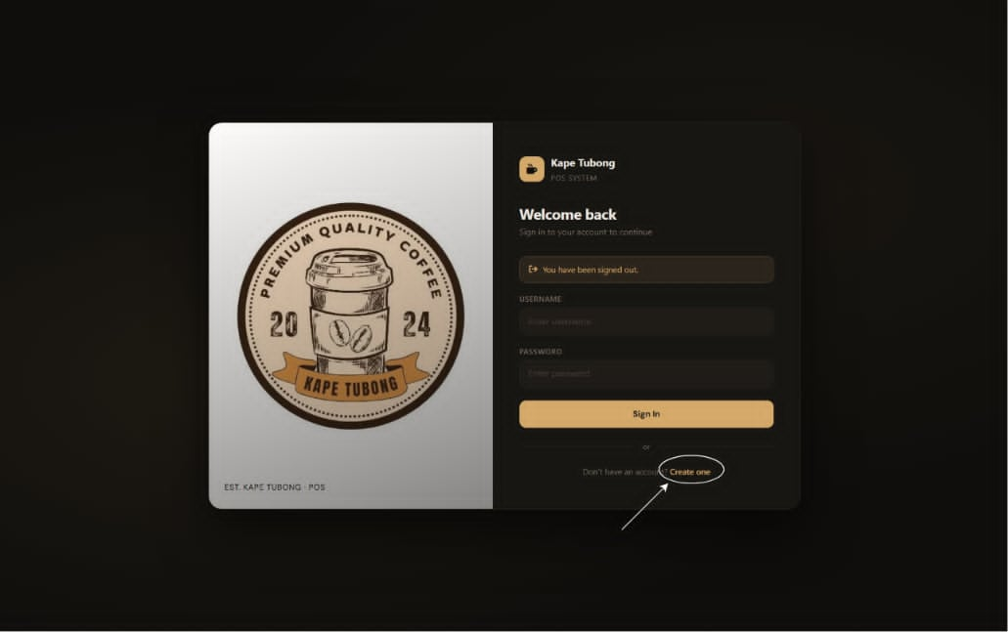
2. ENTER YOUR DETAILS
Enter your desired username and password.
3. CLICK CREATE ACCOUNT
Click Create Account to submit your request.
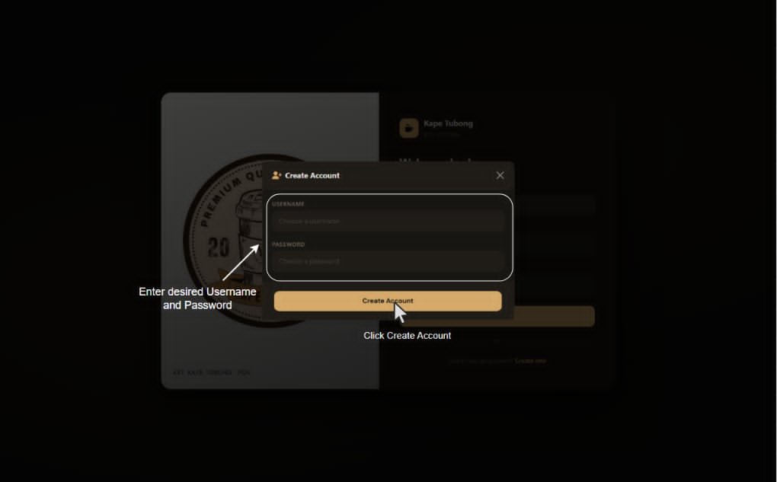
PLACING A NEW ORDER
1. SELECT NEW ORDER
From the side menu, Click New Order.
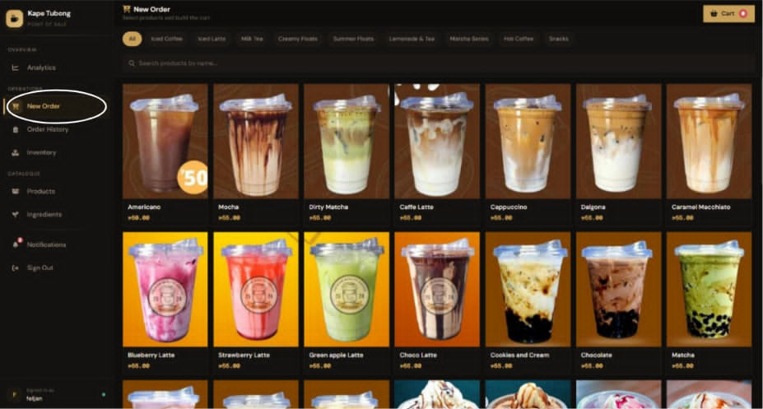

2. BROWSE PRODUCTS
Browse products using the category tabs or the search bar to find the product you want to add.
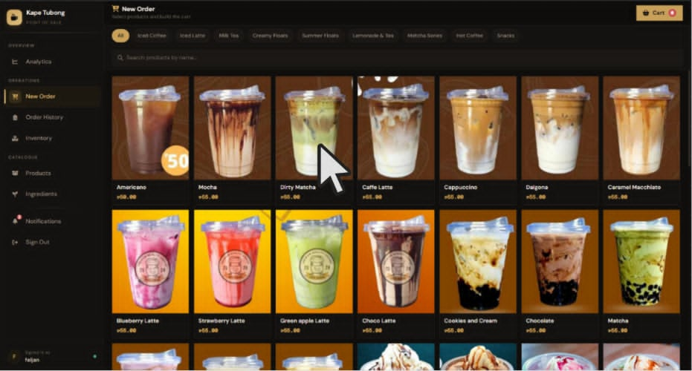

3. ADD ITEM TO CART
Click a product to add it to the cart. The item will appear in the cart tab with its name and price.
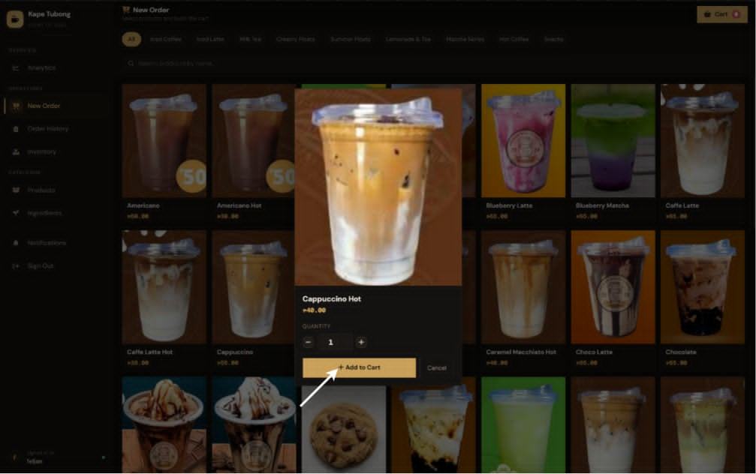

4. ENTER CUSTOMER NAME
- Enter Customer Name
Type the customer’s name in the Customer Name field in the cart.
- Review Payment
Check the subtotal, enter the amount paid by the customer, and the system will automatically compute the change.
- Place or Cancel Order
Click Place Order to finalize the process, or click Cancel & Close.
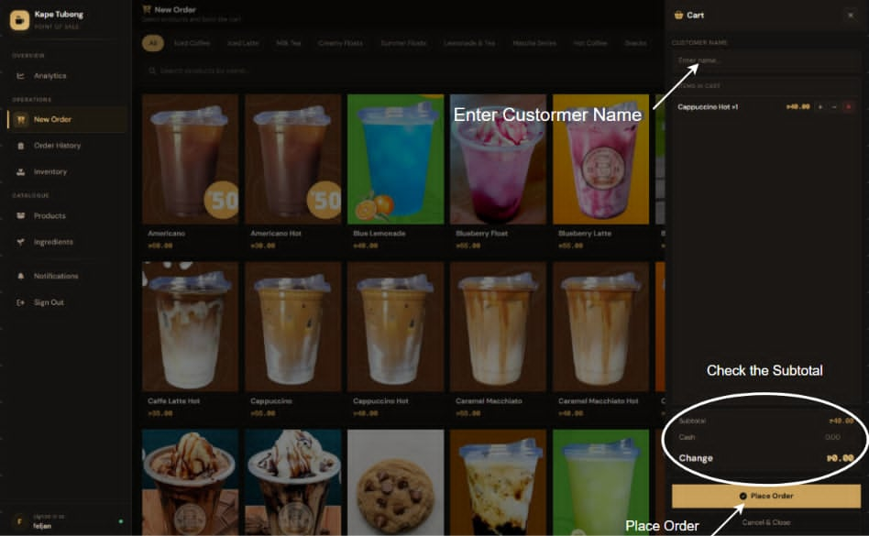

ORDER HISTORY
1.Select Order History from the side menu.
2.You will be displayed with the overview, showing the total number of orders, revenue and visible orders.
3.Use the search bar to search for orders based on customer name or product.
4.Apply the pre-defined filters of time period such as: Today, Last 7 Days, This Month or All Time. You can select your own period of dates through the calendar button and apply filters based on price too. Click Clear to remove all filters.
5.The table shows customer name, product purchased, quantity, subtotal and the date of order. Click any column title to sort your results.
6.Click Export CSV to export your filtered list.
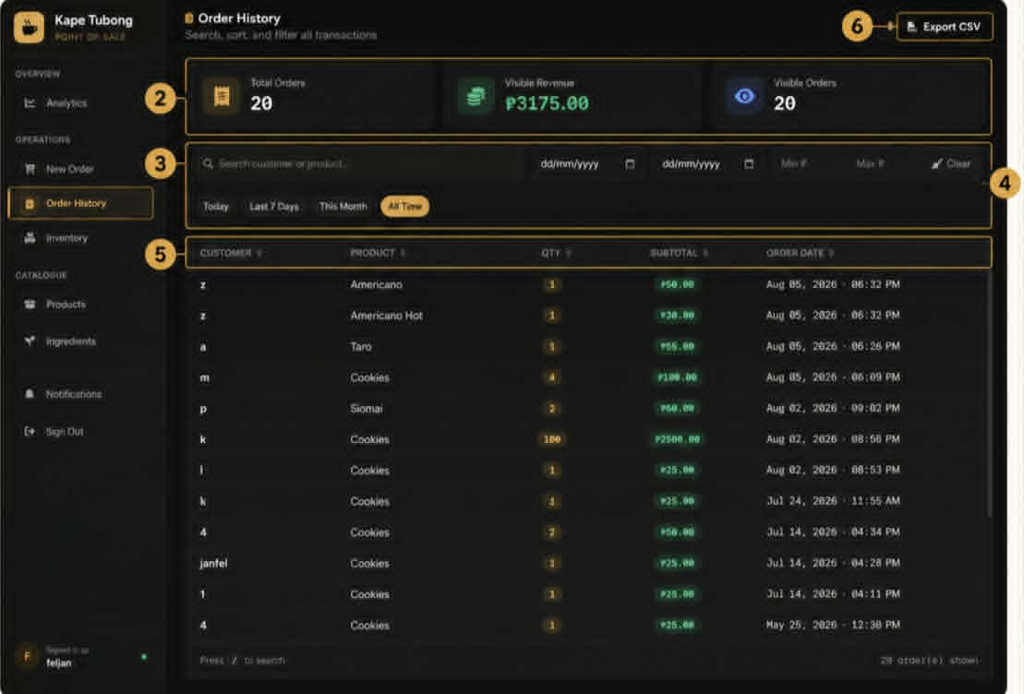

INVENTORY MANAGEMENT
Checking Ingredients
-Go to Inventory via the side bar. Stock tab is where you will find all the ingredients with their respective quantities and status like in Stock, Low Stock, or Out of Stock.
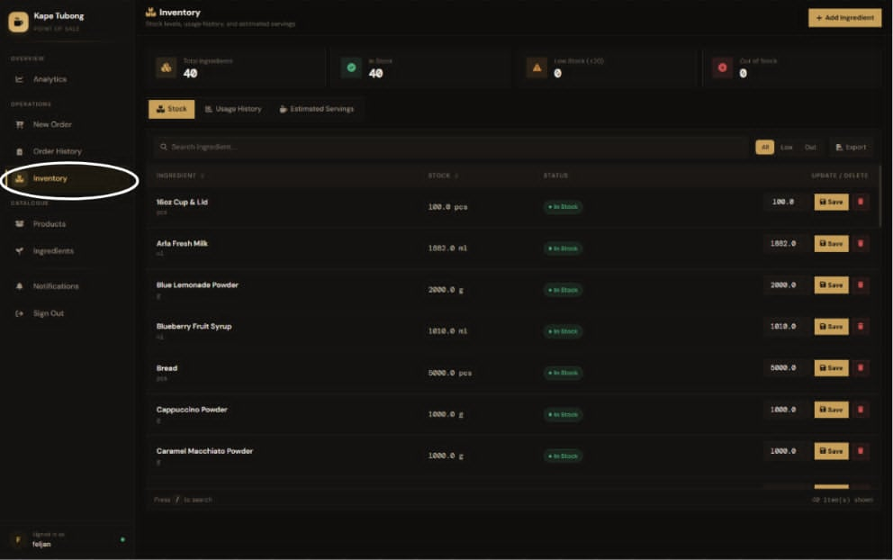
-Find a certain ingredient and update its quantity in the list and press Save to confirm. You may also use the delete button to get rid of the particular ingredient.
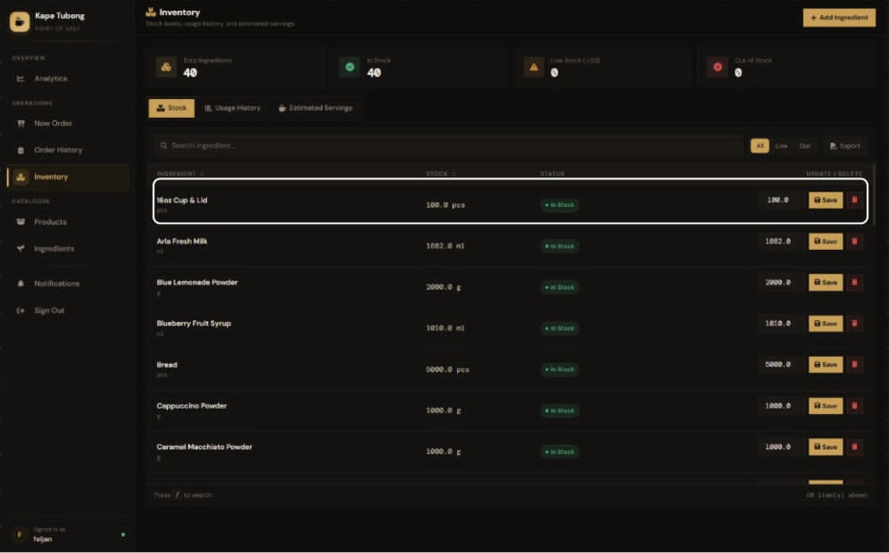

-Press the Add Ingredient button to add another ingredient to your inventory.
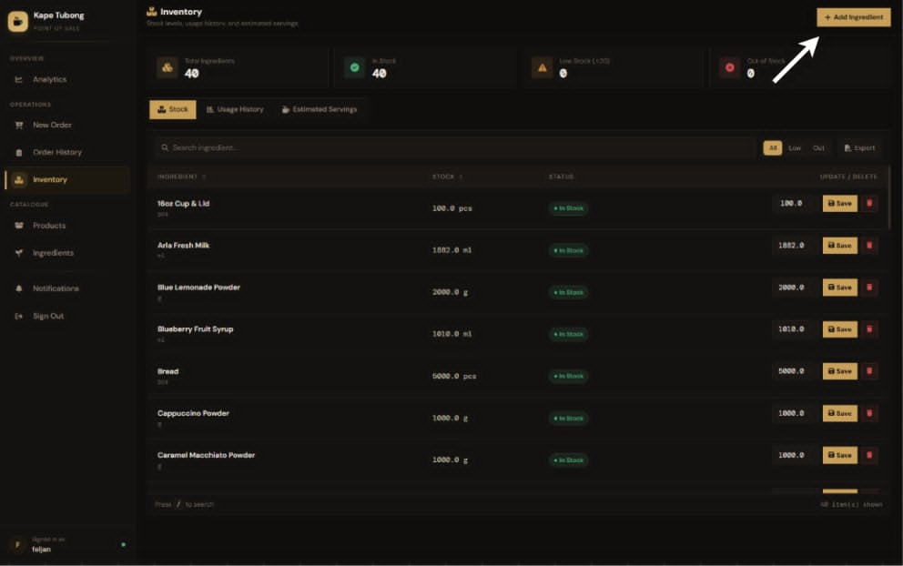

MONITORING INGREDIENT USAGE
- In the Usage History tab you will be able to check the usage of your ingredients for some certain periods (7 days, 30 days, all time). Information that will be provided includes the total quantity of usage, average quantity per order, and number of orders processed.
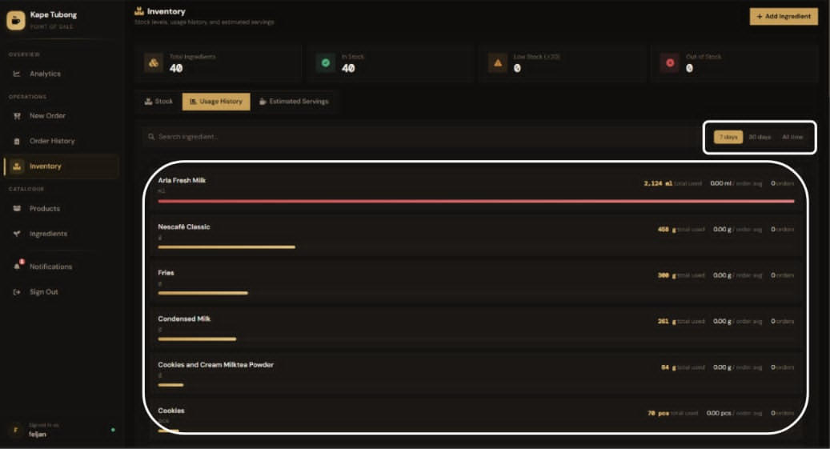

ESTIMATING PORTIONS
- In the Estimated Servings tab you will see how many portions of each item on your menu you can prepare depending on your ingredients' stock. This view also provides you with the information about which ingredient you will run out of first.
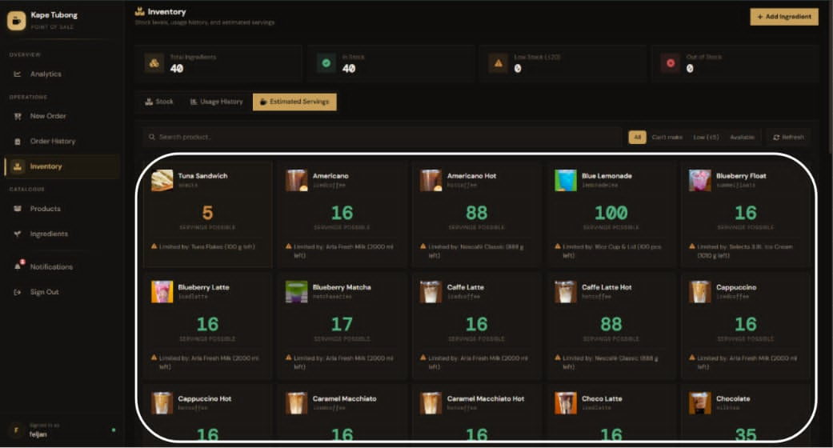
PRODUCT
MANAGING YOUR PRODUCTS
1. Go to Products to see your whole menu catalogue. Total number of products and categories will be displayed at the top.
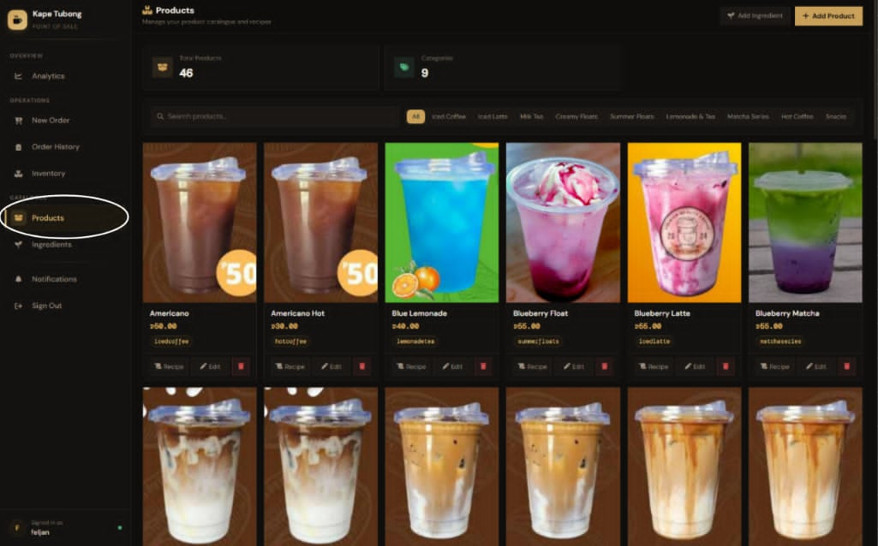

2. You may search for certain products or filter them using the available buttons.
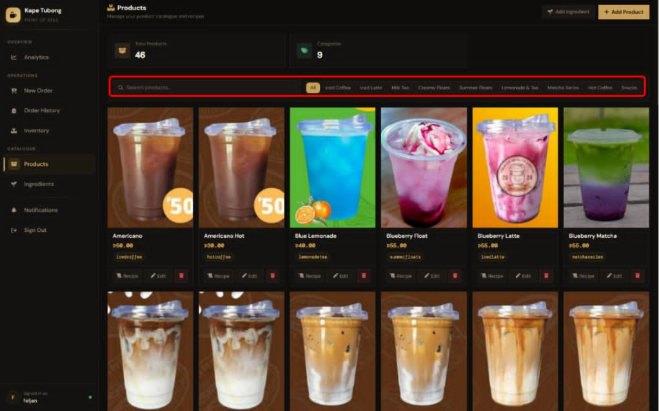

3. Every card shows a product image, name, price, and category. You can use the buttons below the item to:
- Recipe — see or create a recipe of ingredients for this product;
- Edit — change any data regarding this product;
- Delete — remove the product from the menu.
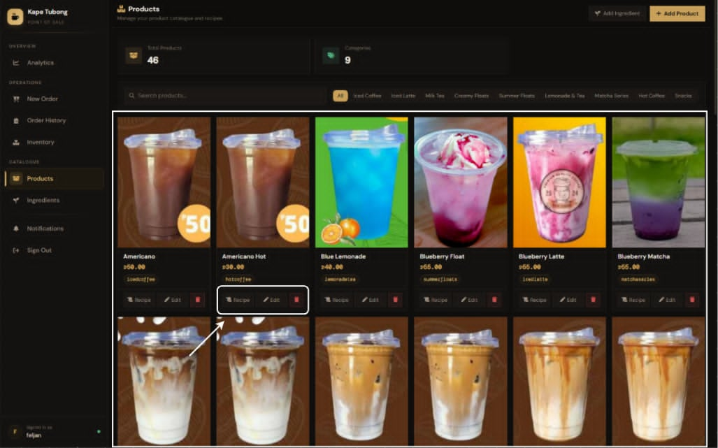

CREATING A NEW PRODUCT
1. Select Add Product to begin creating the new product entry.
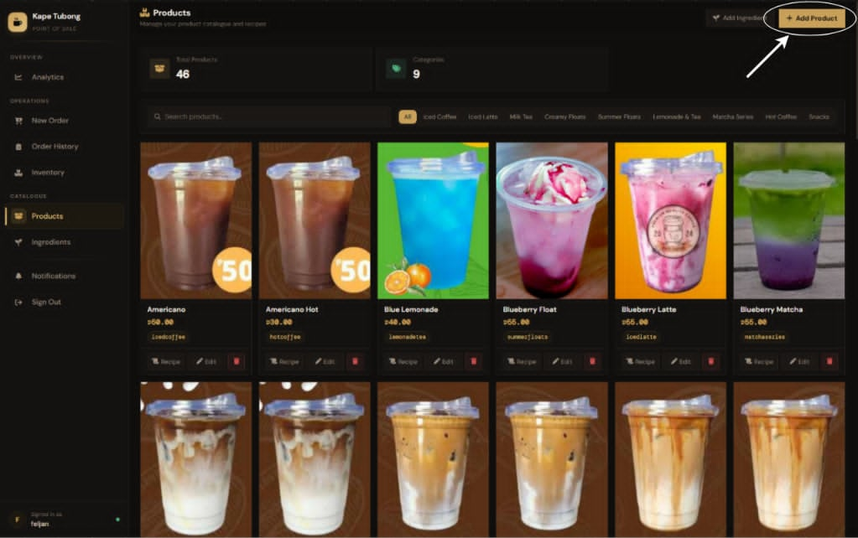

2. Fill in the name of the product, set its cost in Philippine Peso (₱), and assign an appropriate category.
3. Upload the product picture (JPG, PNG, WEBP formats, up to 5 MB maximum size) by selecting or dragging the file onto the file upload area.
4. Create the recipe: press Add Ingredient, select the ingredient, and enter the amount used per sale of the product. Leave the recipe part blank if there are no ingredients in it.
5. Press Create Product to save. The new product will become visible right away on the orders page. Press Back to exit without saving.
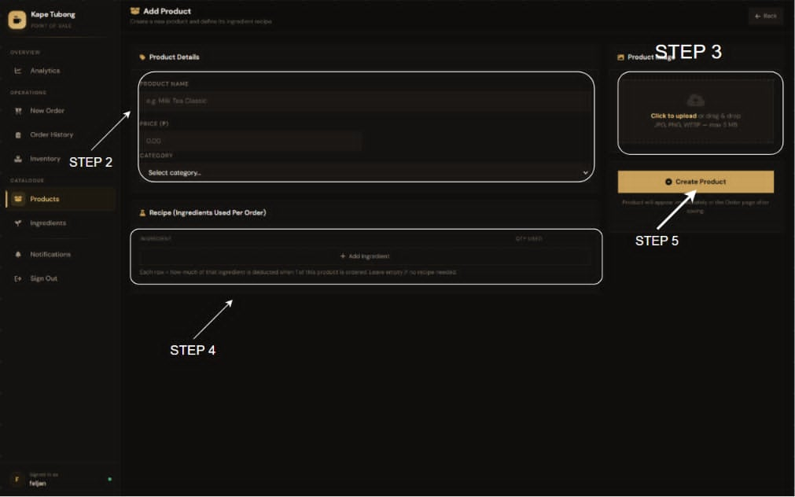

MANAGING INGREDIENTS
1. Go to Ingredients in the side panel.
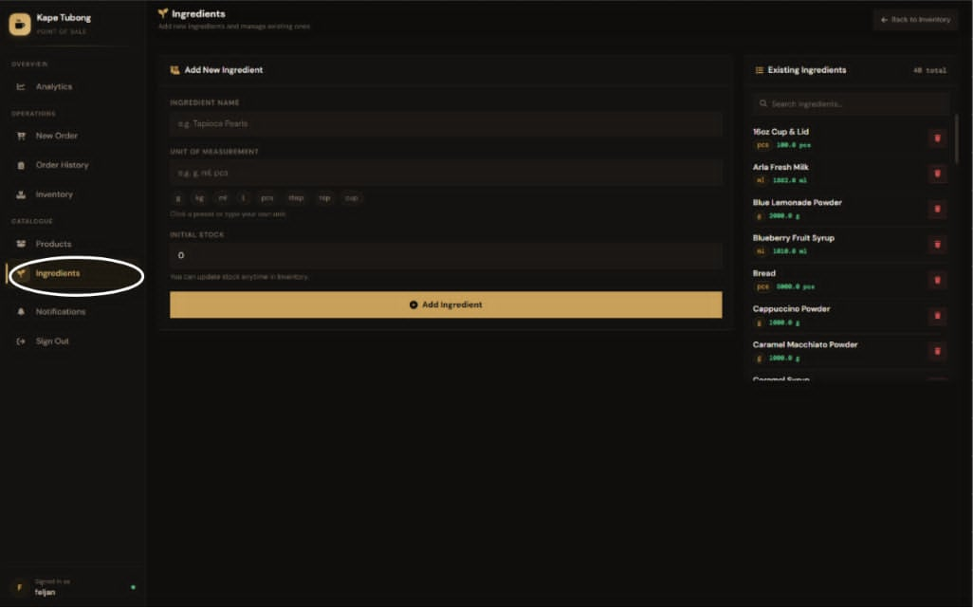

2. Enter the ingredient name, enter the desired unit of measurement (g, kg, ml, L, pcs, tbsp, tsp, cup), and set the initial quantity of the stock.
3. Press Add Ingredient to save the new item.
4. On the right-hand side you will see the full list of ingredients and their stock. You can search for them by name or delete any unnecessary item from it. Press Back to Inventory when done.
